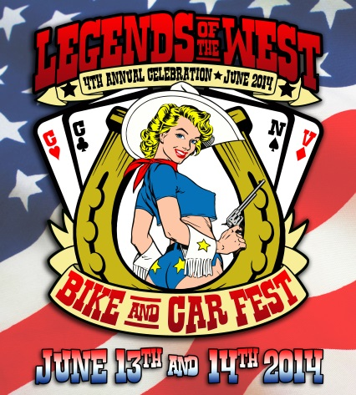**Legends of the West Bike & Car Fest**

is coming to Carson City on **June 13 & 14, 2014**. The planning for this event is going fast and furious and we are anticipating a great third annual show. Downtown Carson City will thrill to the deep-throated vroom of motorcycle engines from 250cc to over 900cc and classic auto engines from 4 cylinder to giant V10s!

The local chapters (#1 and #7) of the Disabled American Veterans (DAV) and the F.I.S.H. Food Bank will benefit from **Legends of the West.**

Main Street will be closed from Robinson to the Capitol so that all the bikes and cars can be viewed by the public. The **Carson City Sheriff’s Office 11th Annual Extreme Motor Officer Training Challenge** will take place right here on our own downtown streets. See these highly trained men and women compete for glory in slow motion!

Activities include: Live Entertainment, Show & Shine, Raffles, Breakfast, Awards, and more...

Sponsorship is a great “fit” for your community-oriented and promotional-minded business. You can get your message out, publicize your product and services, and boost name recognition while supporting this exciting new family-friendly event. We can design a sponsor package specifically to meet your business needs, or you can select your sponsor level from the list below. Either way, you will be part of Carson City’s future and a friend of downtown’s great history.

|  |  |  |  |  |
| --- | --- | --- | --- | --- |
| Benefit | $1,000 Level | $500 Level | $250 Level | $100 Level |
| Ride pins or Dash plaques | Yes | Yes | Yes | Yes |
| T-shirts | Yes | Yes | Yes | Yes |
| Website | Tile with Link | Tile with Link | Tile with Link | Listing |
| Booth space opportunity | Yes | Yes | Yes | Yes |
| Coupons/ads in Goodie Bags | Yes | Yes | Yes | Yes |
| Public Address Announcements | Yes | Yes | Yes |  |
| Your logo in event advertising | Yes | Yes | Listing |  |
| Your banner displayed | Yes | Yes | Yes |  |
| Saturday Breakfast at the Elks Lodge | Yes | Yes | Yes |  |
| Be a Judge or Presenter | Yes | Yes | Yes |  |

We offer a special “deal” to our downtown restaurants. For any level of sponsorship, you can place a booth in front of your restaurant, in your entryway, on the sidewalk, or in the street. No competing food booths will be solicited.

Please contact Arlington Group Events at 775.887.1294 or [info@EventsNevada.com](mailto:info@EventsNevada.com) for more information, to sponsor, to participate, or to vend.

Join us and see for yourself what businesses in Carson City have discovered. By partnering with this successful event, you can boost your business’ profile through support and advertising with the **Legends of the West Bike & Car Fest!**

Regards,

*Maxine & Fred Nietz*

*Arlington Group*

[*info@eventsnevada.com*](mailto:info@eventsnevada.com)

[*www.EventsNevada.com*](http://www.EventsNevada.com)

*775.887.1294*