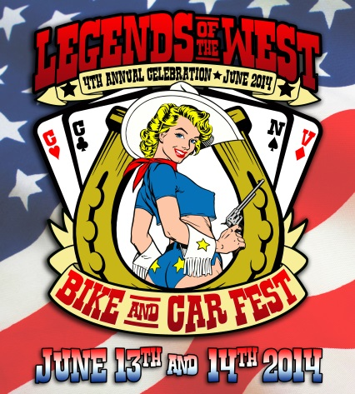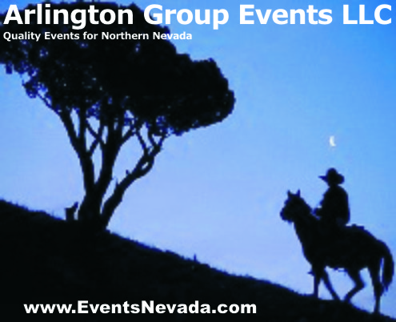Legends of the West

Bike & Car Fest

with the

**Carson City Sheriff’s Office 11th Annual**

**Extreme Motor Officer Training Challenge**

**June 13 & 14, 2014**

**Downtown Carson City**

[www.EventsNevada.com/legends.html](http://www.EventsNevada.com/legends.html)

Dear Business Owner,

Legends of the West Bike & Car Fest is approaching its fourth year. It has been a successful and growing event that benefits our downtown area. Classic cars and motorcycles and vehicles of all descriptions grace our main street and provide the public with a great “strolling” prospect and an opportunity to visit and shop and become familiar with the businesses that anchor our downtown core. This is a family-friendly event that also includes live music, vendor booths, food and drink.

Once again, the **Carson City Sheriff’s Office Annual Extreme Motor Officer Training Challenge** will take place at the north end of the event. Watch these highly trained men and women compete for glory in slow motion! The Challenge attracts entrants from law enforcement throughout the country. You will thrill to their feats of daring-do and admire their expertise on great bikes from all manufacturers.

The Legends Committee works closely with the City, the Visitors Bureau, the Sheriff’s Office, local car clubs, and the downtown merchant group to make it all happen. However, cash is always needed for some expenses. As with any event of this type, sponsorships are necessary to pay the bills. Musicians, port-a-potties, advertising, permits, and entrant “goodie bags” are only a partial list of expenses incurred to bring Legends to Carson City.

We invite you to become a sponsor and enjoy the benefits of sponsorship, including public recognition, web links, event merchandise, Elk’s breakfast, booth space, and the opportunity to be an **Official Judge of the Show N Shine**. If you have a vehicle that you would like to display and participate, we offer that benefit as well. And, speaking of benefits, the local chapters (#1 and #7) of the **Disabled American Veterans** (DAV) and the **F.I.S.H. Food Bank** will benefit from Legends of the West**.**

Please contact Arlington Group Events at 775.887.1294 or [info@eventsnevada.com](mailto:info@eventsnevada.com) for any more information, or visit our web site at [www.EventsNevada.com/legends.html](http://www.EventsNevada.com/legends.html) or visit us on Facebook.

We know you hear from many worthwhile causes in need of funds and we appreciate the chance to bring our event to your attention. As a special gift, attached is a calendar page for JUNE 2014 highlighting the many wonderful happenings in our community during that month – feel free to post it for your customers and your employees.

Regards,

*Maxine & Fred Nietz*

*Arlington Group*

[*info@eventsnevada.com*](mailto:info@eventsnevada.com)

[*www.EventsNevada.com*](http://www.EventsNevada.com)

*775.887.1294*

Legends of the West Bike & Car Fest

**June 13 & 14, 2014**

**Downtown Carson City**

|  |  |  |  |  |  |  |
| --- | --- | --- | --- | --- | --- | --- |
| **JUNE 2014** | | | | | | |
| MONDAY | TUESDAY | WEDNESDAY | THURSDAY | FRIDAY | SATURDAY | SUNDAY |
| 2 | 3 | 4 | 5 | 6 | 7  **Wine Walk**  (Downtown)  [ccdowntown.com](http://www.ccdowntown.com) | 8  **Pops Party Concert**  (Gov’s Mansion)  [ccsymphony.com](http://www.ccsymphony.com) |
| 9 | 10 | 11 | 12 | 13 14 *Flag Day*  **Legends of the West Bike & Car Fest / CCSO 11th Annual Extreme Motor Officer Training Challenge**  (Downtown)  [www.EventsNevada.com/legends.html](http://www.EventsNevada.com/legends.html) | | 15 *Father’s Day* |
| **Stewart Father’s Day Powwow**  (Stewart Indian School)  [**stewartindianschool.com/stewart-fathers-day-powwow.html**](http://stewartindianschool.com/stewart-fathers-day-powwow.html) | | |
| 16 | 17 | 18 | 19 | 20 | 21  **Taste of Downtown**  (Downtown)  [tasteofdowntowncarson.com](http://tasteofdowntowncarson.com/) | 22 |
| 23 | 24 | 25 | 26 | 27 28  **Run What-Cha-Brung**  (Fuji Park)  [karsonkruzers.com](http://karsonkruzers.com/) | | 29 |
| 30 |  |  |  |  |  |  |